**Real time presence detection,identification and authentication through applied computer vision**

**Author 1 | Author 2 | Author 3 | Author 4 | Author 10**

* the post processing takes place on esp32
* Ur protocol
* the computer that execute does everything
* us , in the camera, transmit data in 3 ways 1 ur ,2 i2c to spi , and can interact with the door lock directly , no need for sublayers on the network .
* hooker up server directly to the door.
* their require another host either computer or raspberry.
* their does not work simultaneously , ours 24/7

Abstract

As the requirements of security demands increases and the requirementof saving our environment impacts home systems. Very highly effective systems are highly required and proper encryption method is heavily required too. This the design uses an ESP32-cam development board for face recognition to secure automated home systems (doors, fridges, windows). A homomorphic encryption method is used to tighten the security. The system captures images and compares them to the one saved in it, the ESP32-cam executes everything and there is no need for sublayers on the network. The server is directly hooked up to the door in this case. The systems work simultaneously 24/7 and it does not require another host.

Keywords- Face recognition, Face ID, ESP32-CAM

1 Introduction

Biometric identification technology has advanced quickly in recent years as a result of the pressing need for efficient and secure automatic authentication as well as the rising need for data encryption across a variety of industries. Compared to fingerprint recognition in the field of object feature detection, iris recognition is more user-acceptable due to its directness, friendliness, and other qualities. Face detection technology is widely employed in our daily lives, including mobile payment, video conferencing, and personal identity, thanks to the quick development of artificial intelligence. Face recognition technology is a hot topic both domestically and internationally, with numerous nations starting face recognition research. But there is still room for improvement in face recognition technology's security and identification rate. The major causes of these shortcomings are poor lighting, facial accessory changes, and slow detection speeds, among other things. Based on this, this article presented a Face ID-based lock picking system that also utilized voice wake-up. It also evaluated the accuracy and effectiveness of ESP32-CAM Face identification under various lighting conditions, including various angles, different shades of light, and multiple faces.

Whole system design

Compared to [1] the system in esp32-cam executes all the tasks. All the images are saved in the SD-card and the post processing takes place on esp32-CAM. The results of face recognition is uttered by either the access is granted or not. As long as the users face in inside the camera’s field of view the system can automatically capture the users image , compare it to the previously saved face information and grant access.

2. ESP32-cam hardware circuits

ESP32-CAM serves as the system's main module. An ESP32-based development board is called ESP32-CAM. ESP32-CAM has dimensions of 40 mm by 27 mm. ESP32-CAM is a compact, inexpensive development board based on the ESP32 architecture. It is the perfect option for Internet of Things applications and prototype building.

The board has two powerful 32-bit LX6 CPUs, WiFi, Bluetooth, and low power BLE.

The primary frequency adjustment runs from 80MHz to 240MHz, and it uses a 7-stage pipeline design, an on-chip sensor, a Hall sensor, a temperature sensor, and other sensors.

It may be used as a master mode to construct an independent network controller or as a slave to other host MCUs to add networking capabilities to existing devices. It is fully compliant with WiFi 802.11b/g/n/e/i and Bluetooth 4.2 standards. The ESP32-CAM may be utilized in a wide range of applications. It is appropriate for signals from wireless positioning systems, industrial wireless control, wireless monitoring, and smart home devices.

Two LED indicator lights on the right, one in red and one in white, are used for waking up, networking, facial recognition, and other aspects of the display of different states. One button on the left and one button on the left are used for RST reset and BOOT download, respectively. The video transmission module for the external display screen is connected to the camera, which is perched on top. At the bottom is a microphone that can identify and control voice. The SPI Port, which is the primary data port, is shown in Figure 1 with its hardware configuration.

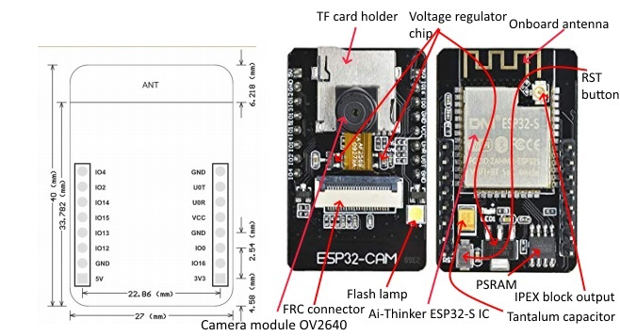

FTDI USB

A shield that connects to the GPIOs on the ESP32-CAM board is the ESP32-CAM AI-Thinker MB programmer. The ESP32-CAM may be programmed using the shield's USB connection thanks to the CH340C USB to serial chip.

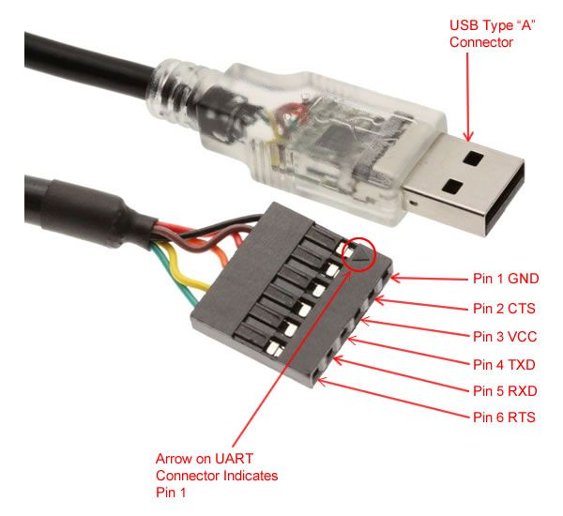

3 ESP32-cam face recognition process

Face recognition is mainly divided into two parts: face information acquisition and face information comparison. After ESP32-CAM is turned on and successfully connected to the upper computer , the camera is already in the working state. After detecting the user’s face, the system will collect the face information and compare it with the previously stored face information , and the comparison results will be directly displayed on the interface of the upper computer.

Face recognition flow chart is shown in figure 2.

The specific operation steps are as follows:

1. After the development board is powered on, it will enter the state of wating to wake up ( the red light is always on the white light is often off). When the user say the wake-up work “Hi Lexin” , the development board wakes up and enters the state of “waiting for networking” (red light flashing , white ligh often off).
2. Usersconnect to the wi-fi hotspots create for the ESP32-CAM.
3. When the user clicks the side button , he can enter “ Enter Face ID” ( the red light is always on ), and the webpage displays: start enrolling. The user faces the camera and start taking portraits. For each successful collection, The red light of The development board will flash , and the webpage can display the corresponding collection times, such as the 1st sample . Users need to capture 3 potrait images.
4. When the boad detects a face, if there is already a Face ID input, the development board will carry out “Face recognition” : if the “ Face recognition” match is successful, the board red ligh flashes once, the webpage displays “Hello ID XXX; if the “Face recognition” match fails , the bard has no response , the page displays “WHO?”. Otherwise , the board only preforms face detection.

4Esp32-cam facial recognition effect

5 Conclusion

**References**

1. Alhamoud, Alaa, et al. "Presence detection, identification and tracking in smart homes utilizing bluetooth enabled smartphones." *39th Annual IEEE Conference on Local Computer Networks Workshops*. IEEE, 2014.
2. Nguyen, Phuc, et al. "Matthan: Drone presence detection by identifying physical signatures in the drone's rf communication." *Proceedings of the 15th annual international conference on mobile systems, applications, and services*. 2017.
3. Beymer, David, and Kurt Konolige. "Real-time tracking of multiple people using continuous detection." *IEEE Frame Rate Workshop*. 1999.
4. Ivanov, B., H. Ruser, and M. Kellner. "Presence detection and person identification in Smart Homes." *Int. Conf. Sensors and Systems, St. Petersburg*. 2002.
5. Shuwandy, Moceheb Lazam, et al. "mHealth authentication approach based 3D touchscreen and microphone sensors for real-time remote healthcare monitoring system: comprehensive review, open issues and methodological aspects." *Computer Science Review* 38 (2020): 100300.
6. Oliver, Nuria M., Barbara Rosario, and Alex P. Pentland. "A Bayesian computer vision system for modeling human interactions." *IEEE transactions on pattern analysis and machine intelligence* 22.8 (2000): 831-843.
7. Kollreider, Klaus, et al. "Real-time face detection and motion analysis with application in “liveness” assessment." *IEEE Transactions on Information Forensics and Security* 2.3 (2007): 548-558.